Artificial Intelligence

PROJECT REPORT

GROUP MEMBERS:

Syed Najeeb Ahmed (20K -1871)

Okasha Arshad (20K-1868)

PROJECT NAME:

Desktop Virtual Assistant

**ABSTRACT**

A Desktop virtual assistant is an AI assistant. It is an application program that understands natural language voice, commands and completes tasks which user say. The project aim to develop a desktop assistant inspiration from virtual assistant like Cortana for windows, and Siri for IOS. Today time is the most important thing to which people are more sensitive no one has time to spoil it and one of the main purpose of this project is to save time. Virtual assistants are software programs that help you ease your day-to-day tasks, such as showing weather reports, creating remainders, making shopping lists etc. Virtual assistant tend to be implemented with the expectation that they can be everything to everyone but when virtual desktop assistant is not answer question properly it’s because it lack the proper context or dose not understand the intent of the question. Bottom line is virtual assistant should not be designed as a set it or forget it solutions.

**PROGRAMMING LANGUAGE USED**

Python

**MOTIVE**

Designing a virtual desktop assistant serves several purposes and can offer numerous benefits, depending on the context and goals of its implementation.

Here are some considerations:

1. **Enhanced User Experience:** Users can interact with the assistant using natural language, making interactions more intuitive, user-friendly and improve the user experience by providing quick and efficient access to information and services.
2. **Task Automation:** Virtual desktop assistants can automate repetitive tasks, freeing users from performing mundane activities. This can lead to increased productivity and efficiency, as users can focus on more strategic or creative tasks.
3. **Efficient Information Retrieval:** With a well-designed virtual assistant, users can quickly retrieve information from various sources without having to manually search through files, documents, or databases.
4. **24/7 Availability:** Virtual desktop assistants can be available round the clock, providing assistance outside of regular working hours and helping global teams collaborate effectively.
5. **Cost Savings:** In some cases, using a virtual assistant can lead to cost savings by reducing the need for human resources to perform certain tasks.

**PROJECT DESCRIPTION**

The project we want to make is a virtual assistant or we can also say an automation tool. The Project we made can perform various roles:

* Search engine with voice interactions(Chrome extensions, opening different websites and etc)
* Camera handling
* Telling date

**MODEL USED**

The model used in such an assistant can vary depending on the complexity of tasks it needs to handle and the level of interaction it needs to have with users.

1. **Rule-Based Systems:** Some virtual desktop assistants use simple rule-based systems to process user input and provide predefined responses or perform specific actions.
2. **Machine Learning and Reinforcement Learning:** For more complex tasks, virtual desktop assistants can leverage machine-learning techniques, including reinforcement learning. These models can learn from user interactions and improve their performance over time.

There might have been advancements in virtual desktop assistant models since my last update. It's important to research the latest tools, frameworks, and models based on your specific requirements and the current state of the field.

**BASIC CONCEPTS USED**

1. **Natural Language Processing:**

To understand user’s speech input.

1. **Automatic Speech Recognition:**

To understand command according to the user input.

1. **Artificial Intelligence:**

To learn things from the user and to store all information about behavior and relations of user.

1. **Inter Process Communication:**

To get important information from other software applications.

**CLASSIFICATION ACCURACY**

The classification accuracy for a virtual desktop assistant can vary widely depending on factors such as the complexity of tasks it is designed to handle, the quality of the underlying models, the size and quality of the training data, and the evaluation criteria used.

**TARGET AUDIENCE**

This project aims to be user friendly, it can vary depending on its features, capabilities and intended uses cases. Here are example from some target audience:

1. **Tech Enthusiasts:** Individuals who are early adopters of technology and enjoy exploring new software and gadgets may find it useful for experimenting with voice.
2. **Accessibility Needs:** People with disabilities or accessibility needs can use desktop virtual assistants to interact with their computers more easily perform tasks hands-free and navigate easily.
3. **Creative Professionals:** Writers, designers, artists and other creative professionals can benefit from virtual assistant for managing ideas, creating to-do lists, setting up reminders, and accessing reference materials.
4. **Casual Users:** Even casual computer users who want an easier way to perform common tasks like checking the weather, searching the web, setting alarms, and playing music can find value in desktop virtual assistants.

**FUTURE PLANNINGS**

1. Making this software powerful to control the whole computer.
2. Writing e-mails.
3. Controlling all websites this voice.
4. Adding eye detection to it.

**WORKING**

Any Virtual assistant consists of three layers:

1. Speech to text
2. Text Analysis
3. Interpret commands

**Speech to text:**

A piece of software used that converts audio to text. It does not understand just anything you might say.

**Text Analysis:**

Converted text is just letters for computer. A piece of software converts text to something that is understandable for computer. Computer understands the command, So Virtual Assistant like siri convert this text to computer command.

**Interpret commands:**

In this layer, that mapped computer command, go to server through internet. Simultaneously, your speech evaluated locally. A local recognizer communicate with server to judge whether command will be best handle locally or not.

Example:

Play Music, Restaurant reservation, Movie Rating

**USER INTERFACE (*for future):**

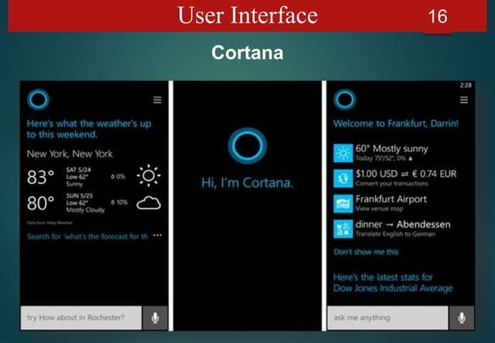

**CONCLUSION**

Virtual Personal Assistants are very effective way to organize your schedule. Now there are many Smart Personal Digital Assistant applications available in market for various device platforms. These new Software Applications are performing really well than PDA devices as they provided with all resources of your smartphone. VPAs are also reliable than Human Personal Assistant because, VPAs are more portable and you can use them anytime. They also have lot of information than any assistant as they are connected with internet.